

GISMONDI 1754:
SIGNIFICANT INCREASE IN CONSOLIDATED OPERATING REVENUE TO 14 MILLION IN 2022, +44% COMPARED TO 2021

The last quarter of 2022 also had double-digit growth (+10%) for the Company wanting to strengthen its position in Europe and Italy, new openings in the Middle East, and consolidation in the United States

Genoa, 23 January 2023– Gismondi 1754 (EGM ticker GIS) , Genoese company listed on Euronext Growth Milan, a producer of highest-end jewellery, communicates consolidated operating results for sales in the fourth quarter 2022 on a voluntary basis (figures not audited), divided by geographical area and sales channel examined by the company’s Board of Directors meeting today.

In the fourth quarter 2022, Gismondi 1754 reported a total consolidated operating turnover of 4,394,597 euro, up +10%, compared to 3,996,320 euro in the fourth quarter 2021. The 4Q growth in sales, +€398,277, mainly due to the Wholesale Europe channel (+22%), market where a good slice of brand business is concentrated. Each channel made its own essential contribution to sales, specifically the Portofino shop which confirmed growth (+47%), and the good initial result for the Rome shop, in Hotel Baglioni Regina, via Veneto, inaugurated last June, and the Prague franchising, continuing to grow on the east European market.

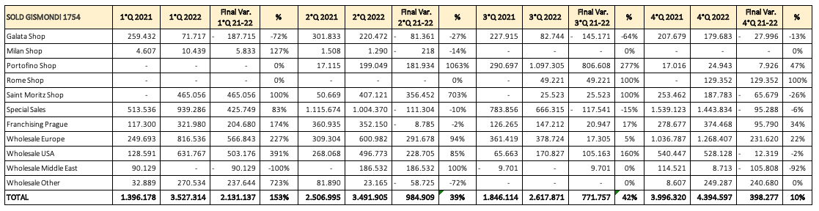

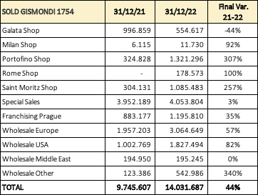

The fourth quarter results are further proof of the extraordinary, continuing growth of Gismondi 1754. Throughout 2022, it generated total revenue of €14,031,687, recording a +44% on the €9,745,607 of the previous year. Continuous year-on-year growth since its Stock Exchange listing in 2019, when the company turnover was €5.69 million. From the IPO till now, Gismondi 1754 has recorded turnover growth of over 147%, thanks to a precise strategy for an extended geographical presence, differing by sales channel.

Analysing the overall figures per sales channel for 2022, the biggest push comes from Wholesale, especially in Europe (+57% compared to 2021) and the USA (+82% compared to 2021). The only channel showing no change compared to 2021 is the Wholesale Middle East, a market only recently opened. For what concerns special sales –the Gismondi 1754 “custom-made”– 2022 closed with a +3%, recording sales for €4,053,804. Essentially in line with the retail channel representing 22% of revenue, against 25% in 2021, and the franchising (Prague) channel, with a 9% effect on revenue against 7% in 2021. It is in the franchising area that Gismondi 1754 finalised an agreement on 16 January in the Gulf Cooperation Council (GCC) area –today including Qatar, Bahrain, Kuwait, Saudi Arabia, Oman and the United Arab Emirates– to open new sales points in the GCC starting from the first half of 2023.

On analysing revenue by geographical area, the Italy area turnover grows to 34% as at 31 December 2022, against 26% in the same period of 2021. As a whole, Europe is worth about 57% of the 2022 turnover of Gismondi 1754, whereas there are no important changes in the incidence of other Countries.

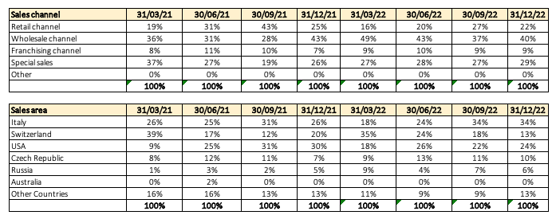

Massimo Gismondi, CEO of Gismondi 1754, commented: “2022 ends with extraordinary growth, so I would really like to thank all our people out in the world representing our brand. The luxury and jewellery market is growing a lot and, in this trend, we are well aware that our growth potential is still considerable. In VicenzaOro, where we launched two new collections, we are meeting with great satisfaction, in line with recent years that have always been prolific for Gismondi 1754. 2023 will be a fundamental year for the brand, with the start of our Middle East expansion, thanks to the recent five-year franchising agreement for a number of openings, and further strengthening in Europe, Italy and the USA. To sustain this new growth stage, we will soon be hiring new managers with considerable experience in the luxury sector”.

About Gismondi 1754:
Handmade in Italy by Italians
Established in Genoa in 1754 with Giovan Battista Gismondi (supplier of Pope Pio VI and the Doria family), Gismondi 1754 - managed by Massimo Gismondi - has achieved a globally acknowledged excellence and competence in jewellery. Massimo Gismondi, known for considering jewels works of art, expresses centuries of craftsmanship and a rich history in his creations, matched with a contemporary style handing down a taste for beauty, a seven-generation company inheritance.

Gismondi 1754 S.p.A.
Via San Vincenzo, 51/1 Genoa
Contact for Investors: Marcello Lacedra
Tel.: +39 010-4074142 Email: investor.relations@gismondi1754.com

EGA
Banca Profilo S.p.A.
Via Cerva, 28 - 20122 Milan
alessio.muretti@bancaprofilo.it
Tel. +39 02 8584808

Press Office
Spriano Communication & Partners
Via Santa Radegonda, 16 20121 Milan
Matteo Russo Mob: +39 347 9834 881
mrusso@sprianocommunication.com
Cristina Tronconi Mob: +39 346 0477 901
ctronconi@sprianocommunication.com

GENOA – MILAN – PORTOFINO – ST. MORITZ – PRAGUE – ST. BARTH – USA – SAINT PETERSBURG
www.gismondi1754.com

